The UAT Defect Log will be used by stakeholders and CTS to track defects/findings during UAT cycles for Vision NG windows. This document provides information as to the reporting process and how to fill out the document.

Initial Defect Reporting
- Open the UAT Defect Log and locate the section of the document with the window name where the defect is occurring.
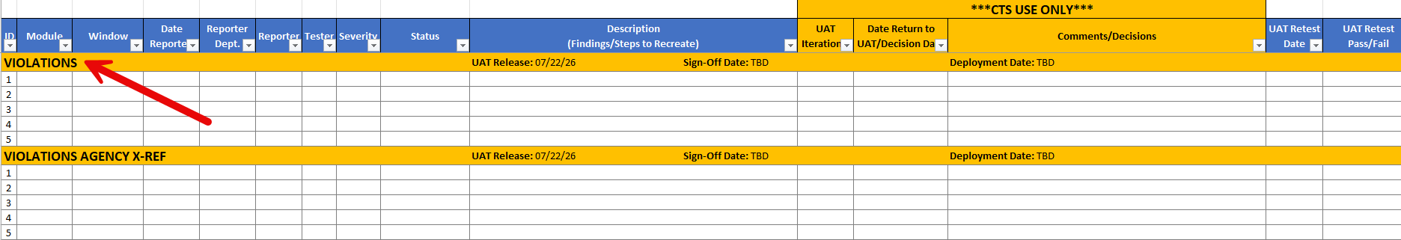
- Update the information in the corresponding cells as follows:
Column | Description
Module | Found by using the menu path Main > Module name (e.g., Tables, Courtroom, etc.)
Window | Name of window
Date Reported | Date reported to CTS
Reporter | Initials of reporter
Tester | Initials of tester
Severity | Select one of the following:  - High – equivalent to showstopper defect, cannot pass UAT without fixing defect  - Medium – should be addressed but not a showstopper defect  - Low – finding/defect that can pass UAT but should be addressed later or an enhancement
Status | New
Description (Findings/Steps to Recreate) | Provide a description of the issue and exact steps taken to replicate the issue
- Once UAT cycle is completed, Reporter will email CTS and advise defects were added. CTS will review and update the document as follows:
Column | Description
Status | Fix In-Progress: defect will be worked  No Action: defect will not be addressed
UAT Iteration (CTS use only) | UAT Cycle where defect was reported
Date Return to UAT/Decision Date | Date Return to UAT: defect passed QA and released to UAT  Decision Date: used with ‘No Action’ status
Comments/Decision | Additional information to support Status column
- If a defect will be worked on, the issue will be retested and released back to stakeholders for testing. See Fix In-Progress for subsequent steps.

Fix In-Progress
- Once CTS completes testing the fixed defect and it is ready for UAT, the UAT Defect Log will be updated as follows:
Column | Description
Status | Returned to UAT: available for testing
Date Return to UAT/Decision Date | Date released to UAT
Comments/Decision | Additional information on fix implemented (if needed)
- CTS will send out an email advising defect log has been updated/fixes have been released to UAT. See UAT – Pass or UAT – Fail for subsequent steps.

UAT - Pass
- If testing is successful, Reporter will update the log as follows:
Column | Description
Status | Resolved
UAT Retest Date | Date retested
UAT Retest Pass/Fail | Pass or Pass with Comments

UAT - Fail
- If testing is unsuccessful, Reporter will update the log as follows:
Column | Description
Status | Returned to CTS
UAT Retest Date | Date retested
UAT Retest Pass/Fail | Fail
- CTS will review and update the following columns:
Column | Description
Status | Fix In-Progress: defect will be worked
UAT Iteration (CTS use only) | UAT Cycle where defect was reported
- See Fix In-Progress for subsequent steps.

